**Document detailing the setup process;**

Step 1: Select Your Operating System (OS)

* Downloaded and Installed Windows 11:
* Visited the Microsoft Windows 11 download page.
* Clicked on the “Download now” button to get the Installation Assistant.
* Ran the Installation Assistant and followed the on-screen instructions to install Windows 11.

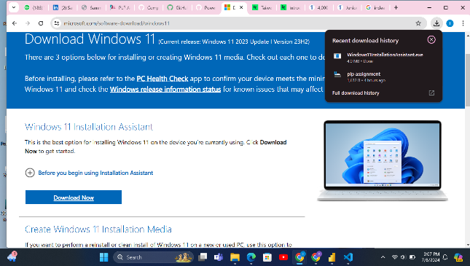

Step 2: Install a Text Editor or Integrated Development Environment (IDE)

* Downloaded and Installed Visual Studio Code:
* Visited the Visual Studio Code download page.
* Chose the version for Windows and downloaded the installer.
* Ran the installer and followed the prompts to complete the installation.

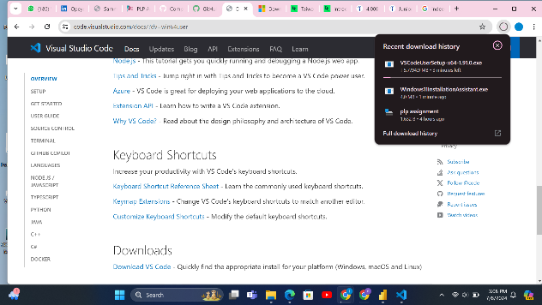

Step 3: Set Up Version Control System

* Installed Git and Configured Git:
* Visited the Git download page.
* Downloaded and ran the Git installer, following the setup instructions.
* Configured Git with my username and email:

Created a GitHub Account:

* Went to GitHub and signed up for an account.
* Initialized a Git Repository
* Created a new directory for the project
* Created a .gitignore file to specify untracked files.
* Made my first commit.

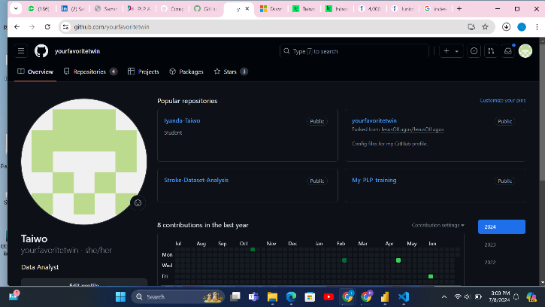

Step 4: Install Necessary Programming Languages and Runtimes

* Installed Python
* Visited the Python download page.
* Downloaded the latest version for Windows.
* Ran the installer and checked the option to add Python to PATH during the installation.

Step 6: Configure a Database (MySQL)

* Downloaded and Installed MySQL
* Visited the MySQL download page.
* Downloaded the MySQL Installer.
* Ran the installer and followed the setup wizard, choosing the "Developer Default" setup type.
* Configured the MySQL Server and MySQL Workbench.

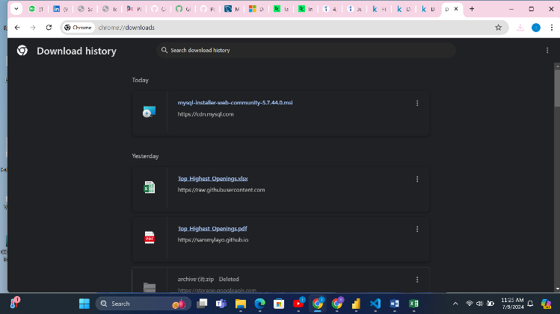

Step 8: Explore Extensions and Plugins

* Enhanced Visual Studio Code Functionality
* Opened Visual Studio Code.
* Went to the Extensions view by clicking the Extensions icon in the Activity Bar.
* Searched for and installed the following extensions:
* Python
* GitLens

GitHub Repository

Sample Project Initialization

Created a GitHub repository named MyProject.

Initialized the repository locally and pushed the initial commit

Included a .gitignore file to ignore unnecessary files.

Repository Link: <https://github.com/yourfavoritetwin/MyProject/tree/master>